**Grove - Chainable RGB LED**

窗体顶端

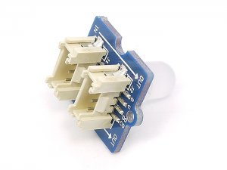

http://www.seeedstudio.com/depot/includes/templates/pure_green/images/next_l.gif

* [http://www.seeedstudio.com/depot/bmz_cache/4/4ed00c824e41b7e7a60a918c764f6a76.image.55x41.jpg](http://www.seeedstudio.com/depot/images/product/chanbalelednb1.jpg)
* [http://www.seeedstudio.com/depot/bmz_cache/0/02e6cb103b44482c93972877b7b3309d.image.55x41.jpg](http://www.seeedstudio.com/depot/images/product/chanbalelednb1_01.jpg)
* [http://www.seeedstudio.com/depot/bmz_cache/5/5c1dd96dc67af610a748b2440c692c0a.image.55x41.jpg](http://www.seeedstudio.com/depot/images/product/chanbalelednb1_02.jpg)

http://www.seeedstudio.com/depot/includes/templates/pure_green/images/next_r.gif

* **Price:**

$3.90  [(Price Feedback)](javascript:void())

* **SKU:**

COM53140P

* **Weight:**

4Gram

* **Units in Stock**

37

* **Designed by:**

[Seeed Studio](http://www.seeedstudio.com/)



[Other products from designer](http://www.seeedstudio.com/depot/seeed-studio-m-23.html)

* **Quantity:** Max: 37  
  
* [Add to Wish List](http://www.seeedstudio.com/depot/index.php?main_page=un_wishlist&products_id=850&cPath=156_157&action=un_add_wishlist)

Description

Chainable RGB LED Twig is based on P9813 chip which is a full-color light source LED driver chip,can provide constant current drive and modulated output of 256 gray.Transmission by wire (DATA and CLK), built-in recycling, can enhance the transmission distance.

**Documents**

Please visit our[wiki page](http://garden.seeedstudio.com/index.php?title=Twig_-_Chainable_RGB_LED)for more info about this product. It will be appreciated if  you can help us improve the documents, add more demo code or tutorials. For technical support, please post your questions to our [forum](http://www.seeedstudio.com/forum).

窗体底端